37 King Street
Chappaqua, NY 10514
Ph: 914-861-9161
Fax: 914-861-9160
Email: info@yurkovsky.com
Your Serenity, Inc.®
PRICELIST of Memon technology as of October 1, 2017 (USD)
www.yourserenityinc.com
Please inquire about discounts for special purchases

Highlight (or circle if faxing) the items ordered

DESCRIPTION | Price | Qty. | Total
Phone
memonizerMOBILE- Smart Phone (Available for colors: black or white, cellphone, iPod, MP3 device, smart  phone, cordless phone, landline, baby monitor & even a smart watch!) | 99
memonizerBLUETOOTH (Headset, Bluetooth) (1 packing unit = 2 pieces) | 99
Car
memonizerCAR A – for regular car, midsize SUV | 299
memonizerCAR B – for hybrid car, small CRV, large SUV | 446
memonizerCAR C – for a bus, large CRV | 655
Residence and Office
memonizerCOMBI Single* up to 1050 sq. feet | 860
memonizerCOMBI Standard* up to 2100 sq. feet | 1475
memonizerCOMBI Standard A* up to 3750 sq. feet | 2299
memonizerCOMBI Standard B* up to 5500 sq. feet | 3299
*** The above units are available in the two versions, the original and plug-in. See the versions on page 3. ***
For Drinking and Other Water Usage
memonizerWATER Single up to 1050 sq. feet | 735
memonizerWATER Standard up to 2100 sq. feet | 1001
memonizerWATER Standard A up to 3750 sq. feet | 1615
memonizerWATER Standard B up to 5500 sq. feet | 2281
Note: The actual usage of these transformers does not have to correlate with the size of the house, but rather with actual water consumption. The latter correlates much better with the number of dwellers, e.g., a smaller family that occupies a large house will need a correspondingly
smaller and cheaper Memon transformer.
Swimming Pool (larger sizes available upon request)
memonizerPOOL Single (or for Jacuzzi) up to 13 cubic yard | 877
memonizerPOOL Standard up to 52 cubic yard | 1152
Portable Units
memoinzerWLAN – for wireless (WiFi) routers and modem routers. | 199
memonizerWORKSTATION – for computers, large TVs, heavy electronics, work, at home office, home | 860
memonizerFOOD | 89
memonizerBODY – These are recommended for visiting environments with electromagnetic pollution such as | 125
supermarkets, stores, office, etc. However, these are far from being capable of offsetting
electromagnetic pollution as residence and office memonizer COMBIs can, or memonizer CAR A that is | Small
used for car or to carry on person. | Medium  Large
Small: 5.5 inches circumference Medium: 6.5 inches circumference Large: 7.9 inches circumference
For solar units : memonizerSUN (one needed per converter) | 339
Home Heating Units: Boilers, Burners, Etc. (larger sizes available upon request)
memonizerHEATING Single up to 1050 sq. feet | 490
memonizerHEATING Standard up to 2100 sq. feet | 707
other
memonizerDOG | 114
Book ‘The Memon Revolution’ | 9.99
Subtotal Leave blank (Office Only) | - | -
Eligible Discount
Total after discount
Sale’s Tax Charge(NY 7.38%) Leave blank (Office Only)
Shipping & Handling Leave blank (Office Only) |  | -
Final Total |  | -
Signature: | Date:

Note:
- All of the transformers are removable and transferrable in case of moving, or replacing the target of the items. However, rotating devices on a short-term basis between residence, office, car, etc., is counterproductive.`
- Based on our experience with bioresonance testing and clinical observations, our instructions concerning the installation of residence or office units on circuit breakers have indicated an even higher effectiveness than the ones provided by the company. All of our customers will receive our instructions.
- The installation process is extremely simple and can be completed by a non-electrician within one minute’s time.

Terms of order:
- 30 day return policy, excludes cellphone chips.
- A 15% restocking fee will be applied to all returned items.
- Shipping and handling charge, via UPS as specified by the purchaser, is extra.

Memon devices have not been evaluated by the FDA and, therefore, no health-related claims can be attached to these.
*For standard situations and average electric consumption. For unusually large areas or excessive power consumption, stronger custom units can be ordered and priced on demand.

Date of order:

Name:

Billing / Shipping Address:

City: State:

Zip Code: Country (if other than US:

Phone Number 1: Phone Number 2:

Email:

Check One:

MasterCard American Express VISA
(Discover is not accepted)

CC #:

Expiration:

CVV (Security Code):

Signature:

How did you hear about our products?:

Terms of order:
- 30 day return policy, excludes cellphone chips.
- A 15% restocking fee will be applied to all returned items.
- Shipping and handling charge, via UPS as specified by the purchaser, is extra.

Memon devices have not been evaluated by the FDA and, therefore, no health-related claims can be attached to these.

*For standard situations and average electric consumption. For unusually large areas or excessive power consumption, stronger custom units can be ordered and priced on demand.

37 King Street
Chappaqua, NY 10514
Ph: 914-861-9161
Fax: 914-861-9160
Email: info@yurkovsky.com
Your Serenity, Inc.®
PRICELIST of Memon technology as of January 1, 2017 (USD)
www.yourserenityinc.com
Please inquire about discounts for special purchases

*** Version – 1: Adheres to a circuit breaker box. ***
This is the original version that is installed via its adhesive surface on the exterior of a circuit breaker door, within only a few seconds by a lay person.

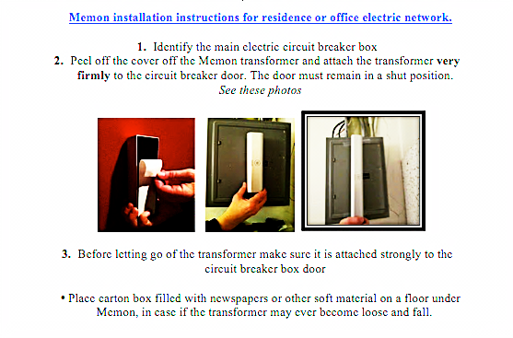

*** Version – 2: Plug in an outlet in any room or area in an apartment, house or office. ***
It is based on the same protective mechanism and power as the original version.
